Introduction to Software Engineering use case Project Team :

1. Aryan Zaheer- 4350/BSSE/F-21/SEC-B
2. Suleman Faiz - 4349/ BSSE/F-21/SEC-B
3. Usama Umar- 4356/ BSSE/F-21/SEC-B
4. Saad Ishaq-4355/ BSSE/F-21/SEC-B
5. Mohsin Waheed-4335/ BSSE/F-21/SEC-B

“Go Solutions”

**“Your safety is our priority”**

What is “Go Solutions”?

Go solutions is a search engine. It’s basic purpose is to provide web services and it allows the parents to give their children access to the web making sure that the don’t get tricked while using internet. This project is designed keeping in view the increasing rate of cybercrimes with teenagers.

**“Go Solutions” requirements**

**ADMIN:**

Admin is the service provider. Admin has faculty members responsible for various functioning of the search engine. Admin can control the whole system.

Admin can manage data that is

* **Common Data**: which is non restricted for all users.
* **Sensitive Data**: Which is restricted for under ages and some is also restricted for adults.
* **History Management:** admin can also manage history and can store it in a private storage for security purposes.

**Transaction details:**

When user will pay the charges to bank will update the transactions in the application. Admin can check those updates anytime. In case of any issue, he can consult to bank management team.

**PARENTS:**

**Requirements from Parents:**

1. Parents will need their own CNIC and child CNIC for registration. Once registration is completed, they can keep check and balance on their child.

**Role:**

1. In case of any sensitive search by child, parents will receive an alert through E-mail or text massage. They can restrict that search.

**Transactions Process:**

1. Once parents have paid charges, then they can check transaction history online.

**CHILD:**

1. Child have only access to login, registration will be done by the authentication of parents.
2. Child can use search engine and surf through common data.
3. If child searches some irrelevant data or some risky websites that are banned in that particular region, parents will be informed through an alert about this action.
4. Child have access to see history and also update account.
5. When child reaches legal age, he can update this account through the authentication of parents.

**BANK:**

Bank will play central role with the among customer and service provider, once parents have paid charges bank will generate the transaction details and update it on application. A bank team will be specific for this process whose job will be to provide integration among the users and provider.

a

**Use case Diagrame:**

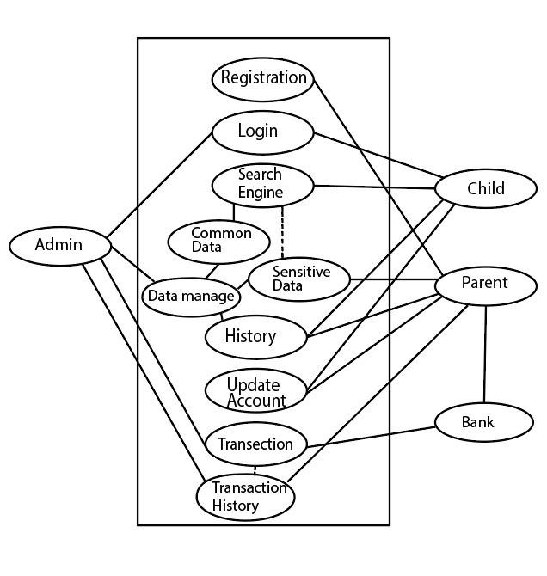

**Domain Model:**



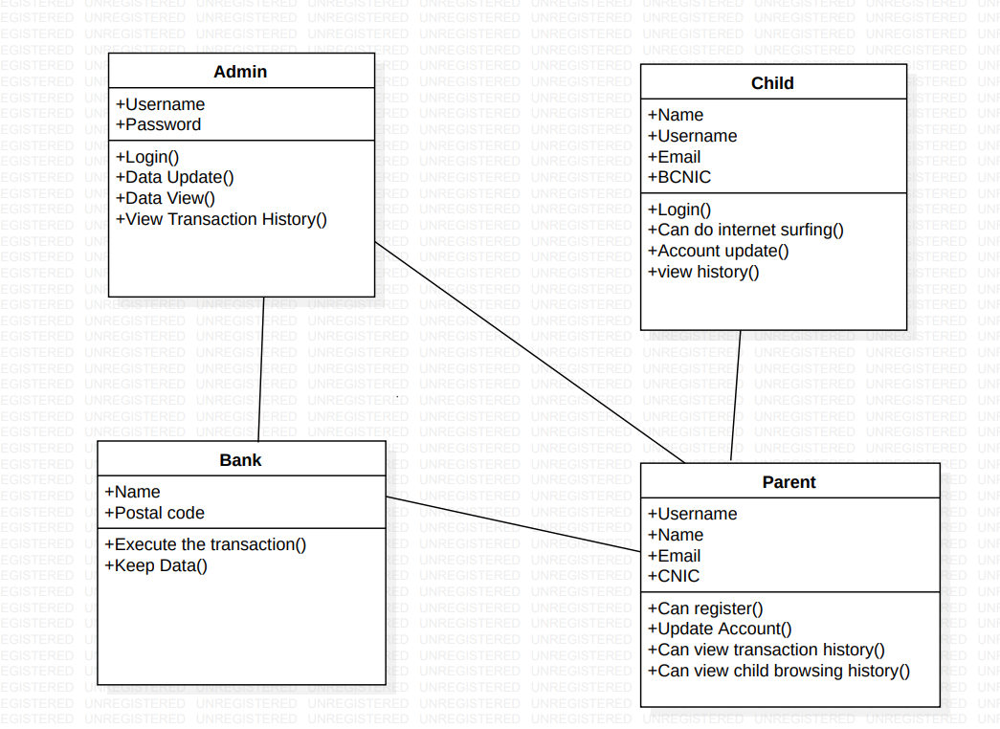

**Characteristics:**

**Admin:**

* Admin can login thorough admin portal, it can manage the whole data and web servers. It can keep the whole data of user for security purposes and can react to certain data accordingly.
* Admin will receive all transaction details through his integration team i.e working with bank. It can take proper actions against the uncertain situations.

**Parent:**

* Parent will have to provide their CNIC’s along with the child CNIC. The registration of account is not possible without the authentication of parent.
* Parent can pay charges online and offline and can check transaction updates on application’s website.

**Child:**

* Child will be use the login page of the account that has been registered by the parents. His all searches will be private except the sensitive searches.
* Any illegal site will be prohibited and parents will get to know about that.

**Bank:**

* Bank will have certain team working with him that will send all the transactions detail on website and will update there.